1. Tidy Gherkin Plugin to generate step definition.
2. 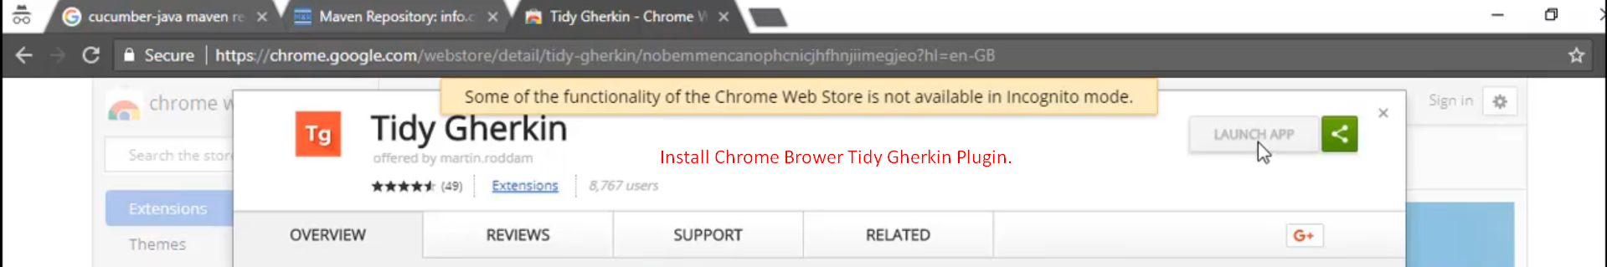
3. 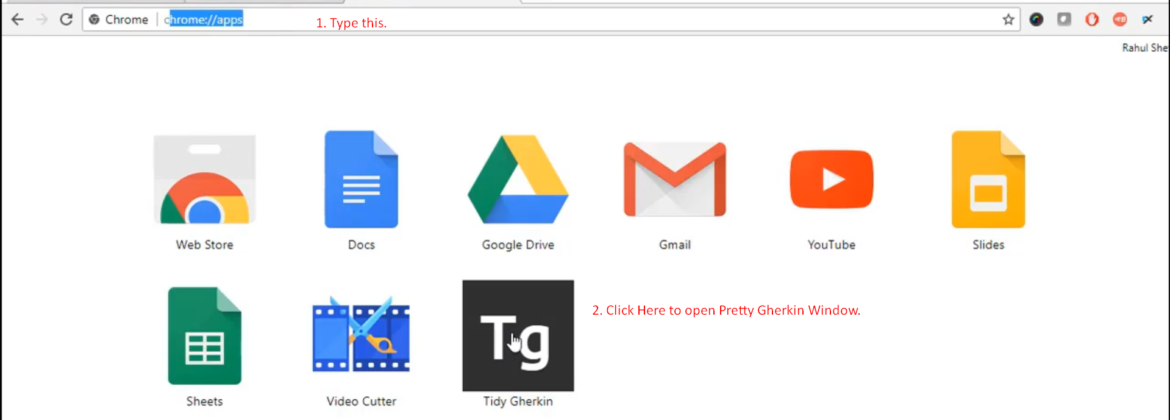
4. 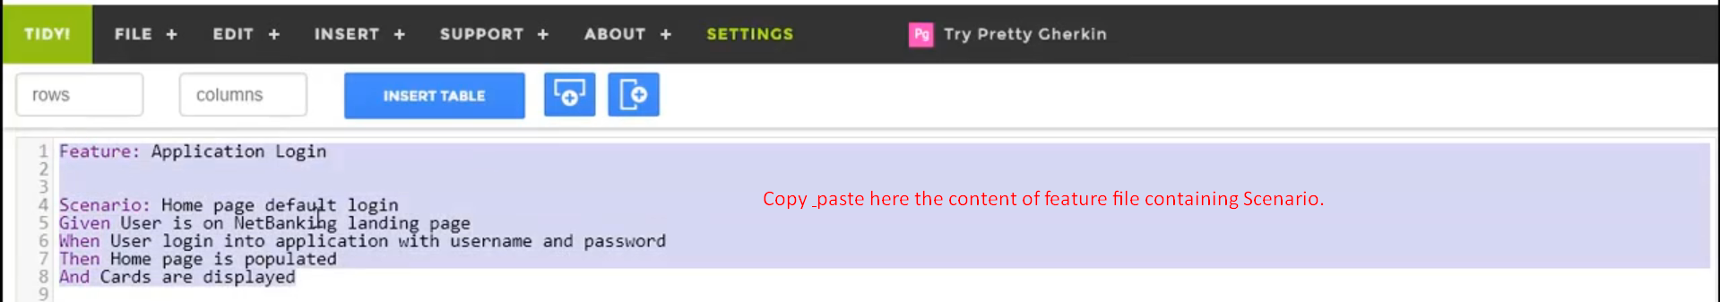Graphical user interface, text, application, email

   Description automatically generated
5. Graphical user interface, text, application, email

   Description automatically generated
6. 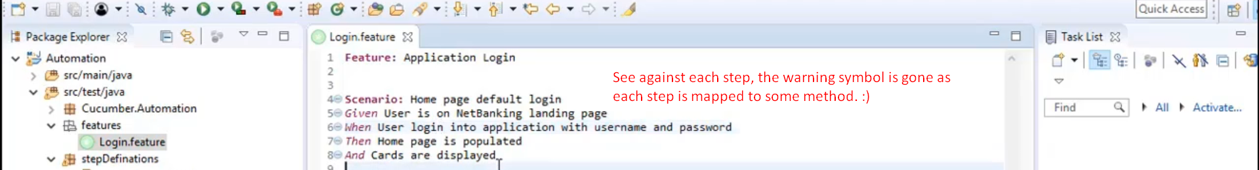
7. 